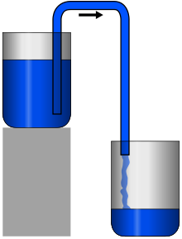
Pump it up
Aim:
To transfer maximum water in minimum time from one glass to another using siphon action.

Apparatus:
straws,plastic bottle,scissor,tape.

Diagram:

What is siphon?
- A siphon consists of a tube connecting two containers with liquids at different levels. Once the tube is filled, for example, by suction, the liquid flows into the lower container until the liquid levels are equalized. The driving force is the difference of hydrostatic pressure, as determined by Pascal's principle.

Judging criteria:
1) The team scoring maximum points becomes winner.
2) Extra points will be given for innovative ideas.

Key Points:
1) Maximum 4 and minimum 3 students allow in team.
2) We will give you only 40 minutes for preparation on site.

Formula:
2* (height of elevation)
+ 0.3(length from beginning of one bottle to ending of another bottle)
+ Innovative ideas out of 20 points
+ Explanation out of 10
- Time = your score

Reference:
https://youtu.be/awq-XP5bV18

If any query for this event contact
Rohan Vaghela- 81601 08978
Jaydeep Sonagra-91068 27074

